

Confidential Charitable Bequest Intention Form

Thank you for including Legal Aid in your estate plan(s). To help us properly acknowledge your generosity, please answer the following questions. Even if you choose to remain anonymous, we are excited to welcome you into 1905 Society. All is confidential.

- I/We have named The Legal Aid Society of Cleveland as a beneficiary of:
☐ My/Our will(s). Please list the name of your Attorney: ___________________________________________________
☐ My/Our trust(s) (please circle one: revocable or irrecoverable). Please list the name of your Attorney: _______________
☐ My/Our IRA or other retirement plan(s). Please list the name of the Administrator: ____________________________
☐ My/Our life insurance policy (or policies). Please list the name of the Issuer: __________________________________
☐ A bank/investment/other account. Please list the Type or Institution: _______________________________________
☐ Other, please describe: ___________________________________________________________________________
- I/We estimate the value of this commitment to be:
☐ $____________________________ ☐ _________% of estate
☐ Unknown / Prefer not to indicate

- My/Our planned gift is to be used for:
☐ The Legal Aid Endowment Fund (the best way to leave a legacy)
☐ For Immediate Unrestricted Use (area of greatest need)
☐ Restricted for a specific practice group/program (please consult with Legal Aid if you are considering a restricted gift to ensure that the proposed restriction can be honored):___________________________________________________

- The Legal Aid Society of Cleveland would like to recognize you for your generosity and include you in The 1905 Society. This group consists of those who have made a planned gift to support the future of Legal Aid.
☐ Yes, you may recognize me/us as a member(s) of The 1905 Society and include my/our name(s) in future publications.
☐ I/We would prefer to remain anonymous and ask that my/our name(s) not be published.

Name: ______________________________ Signature: ______________________________ Date: ____________

Name: ______________________________ Signature: ______________________________ Date: ____________

Preferred Contact Information: ☐ Home ☐ Business

Street Address: _______________________________________ City, State: __________________________________

ZIP: ___________ Phone: ______________________________ Email: _______________________________

Deferred giving is a very personal and private decision. We realize that family situations may change and affect fulfillment of philanthropic intentions. We respect your right to change your mind about your philanthropy.

Please return completed form to:
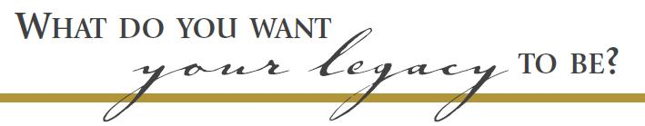
Shauna Mendez, Development & Communications Manager
smendez@lasclev.org
1223 West Sixth Street, Cleveland, Ohio 44113

